**Screenshots needed for Dashboards**

1. **AWS Login screen with username**

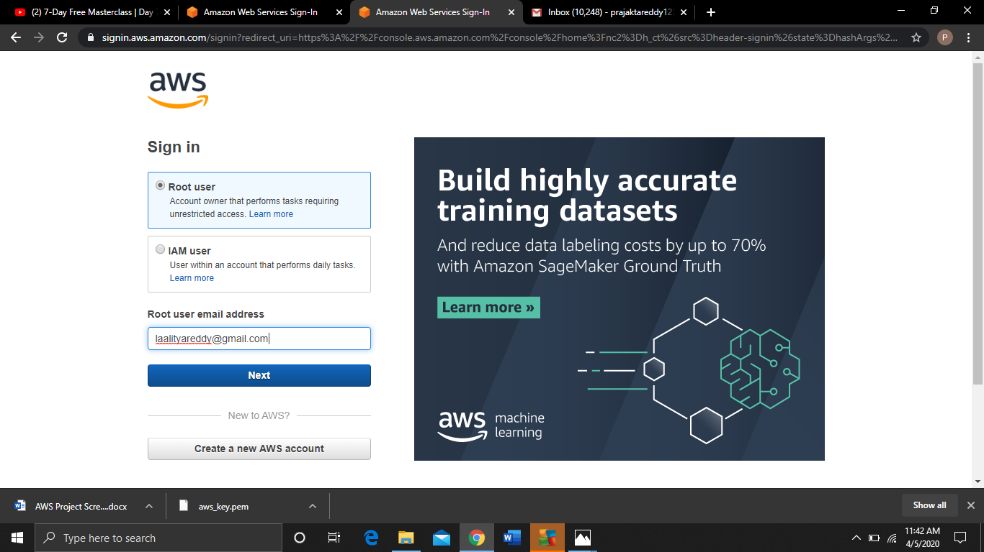

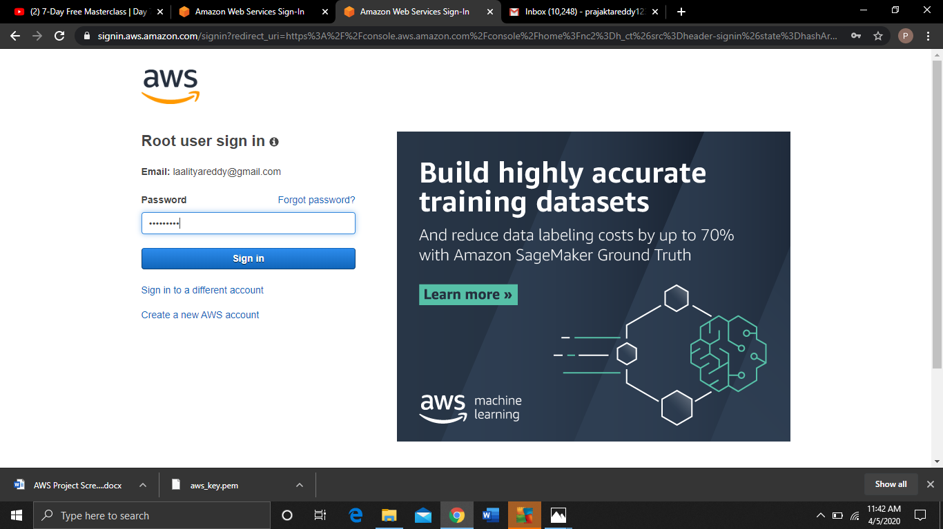

**2)EC2 DASHBOARD**

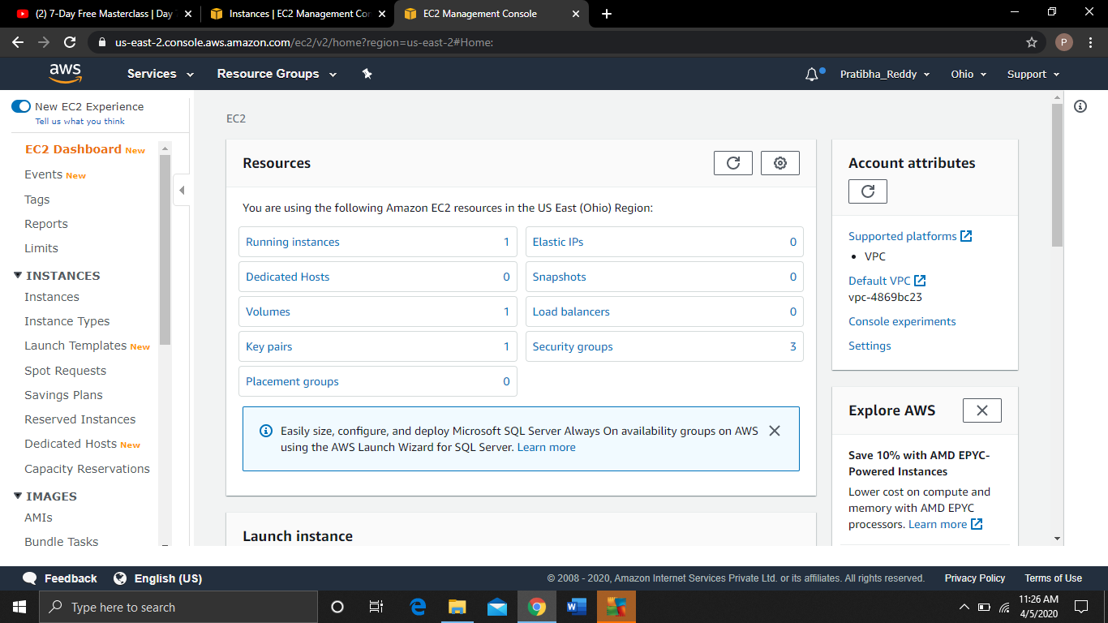

**3) S3 DASHBOARD**

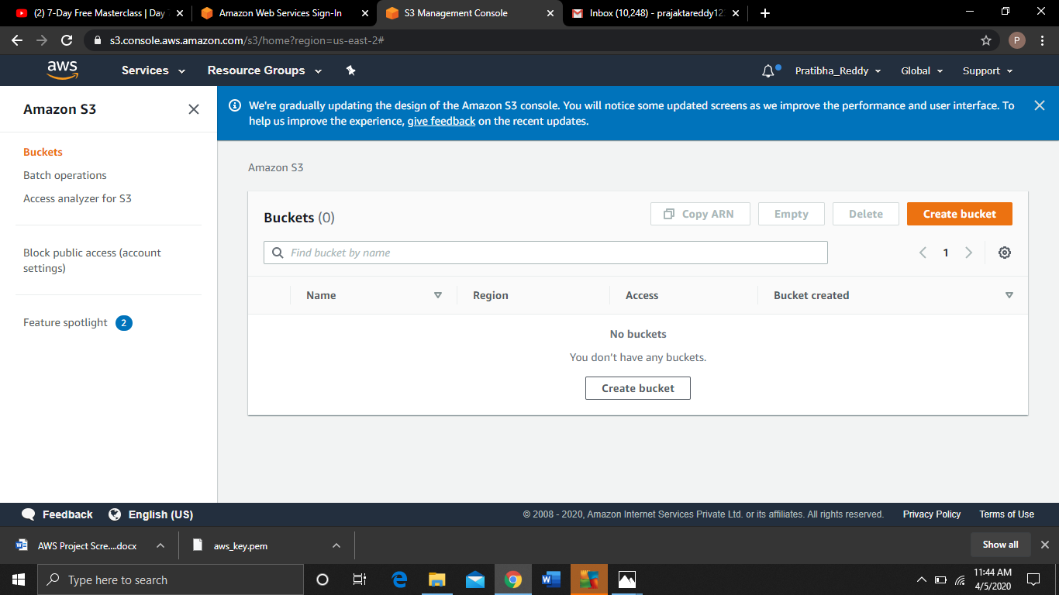

**4) REKOGNITION DASHBOARD**

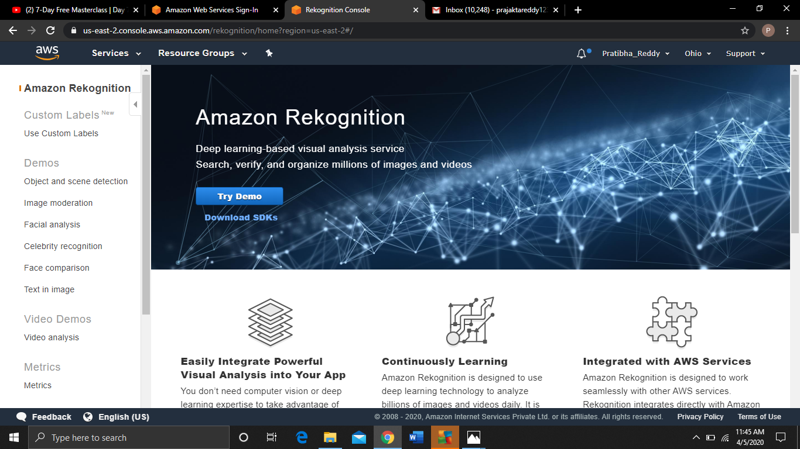

**5. CHOOSING AN AMI**

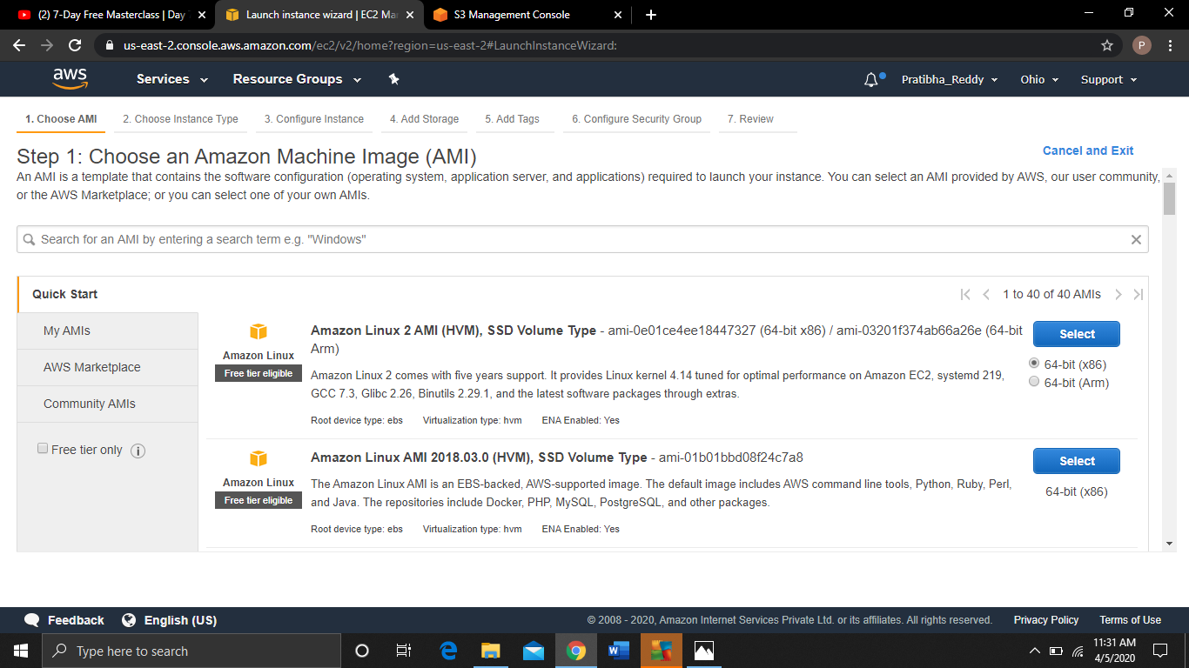

**6. CHOOSING AN INSTANCE TYPE**

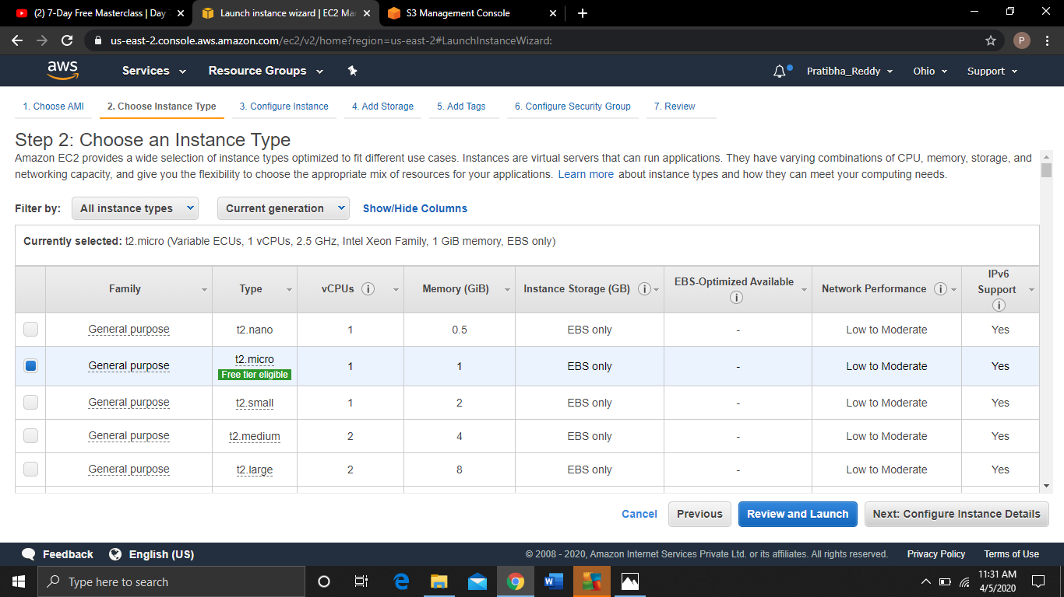

**7. ADDING STORAGE**

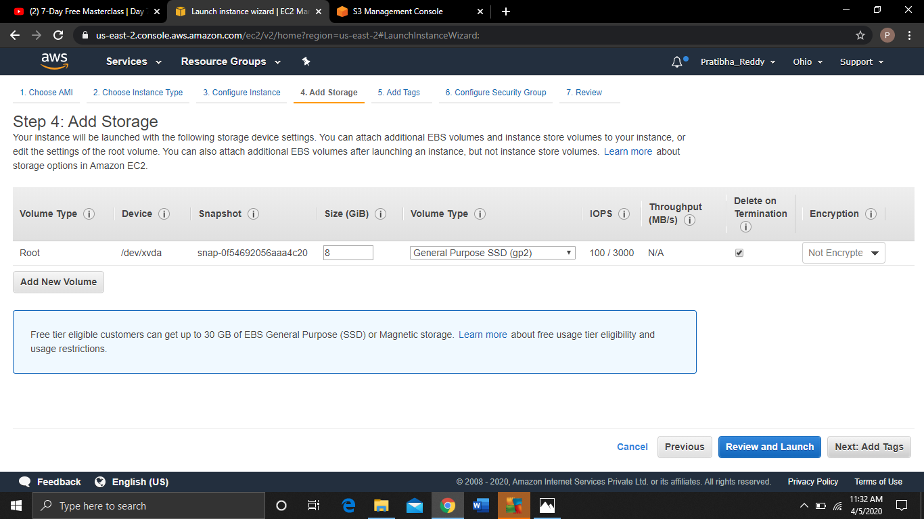

**8. CONFIGURING SECURITY GROUP**

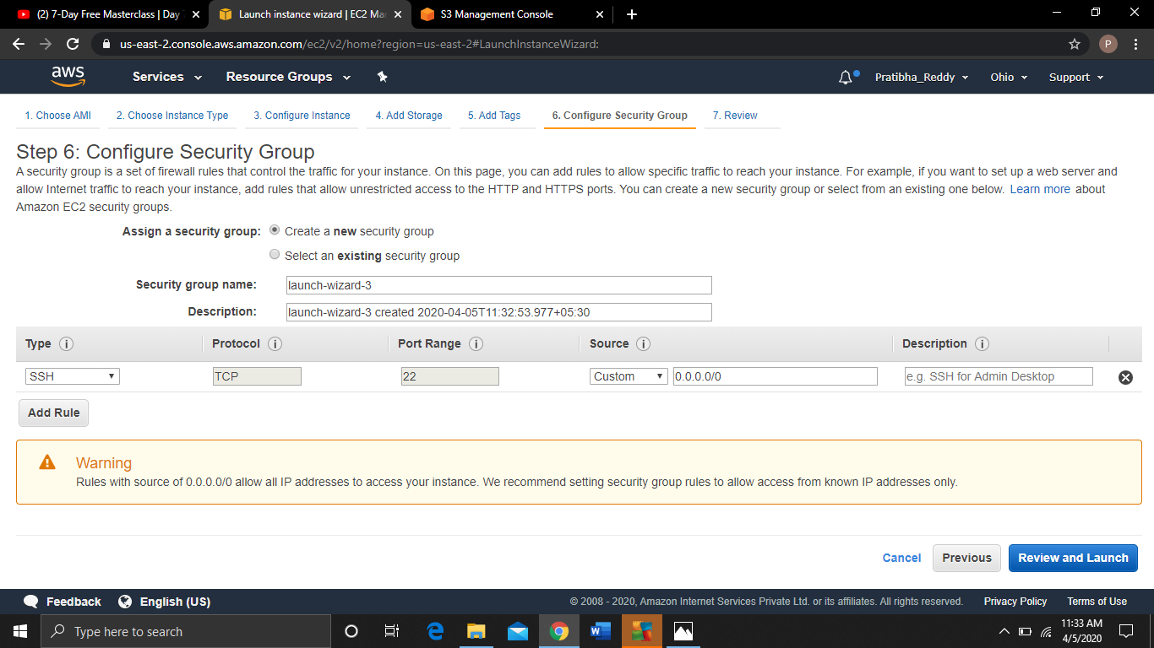

**9. KEY PAIR DOWNLOAD**

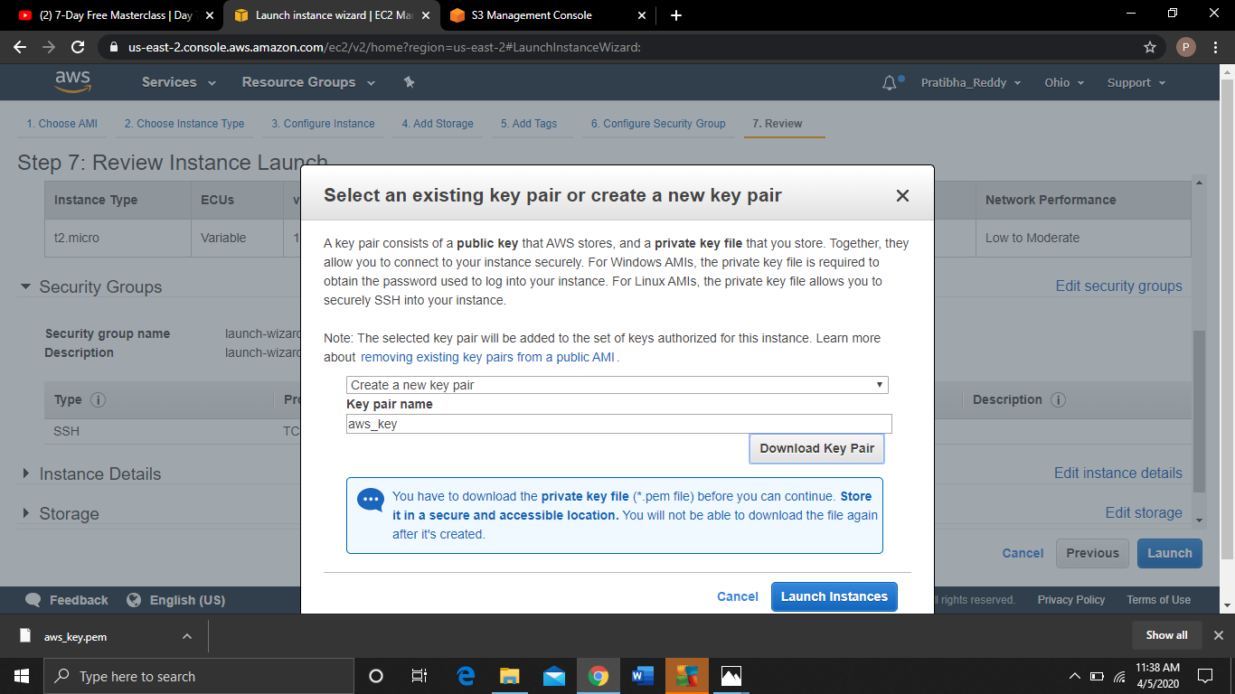

**10. PUTTYGEN CONVERSION**

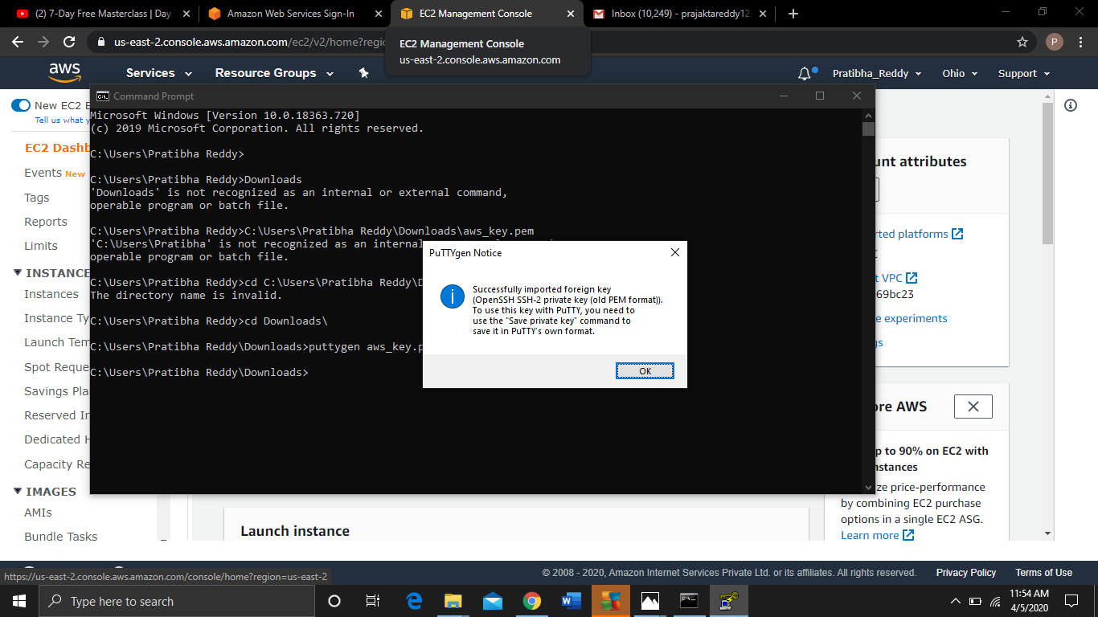

**11. LOGGED IN EC2 BLACK SCREEN**

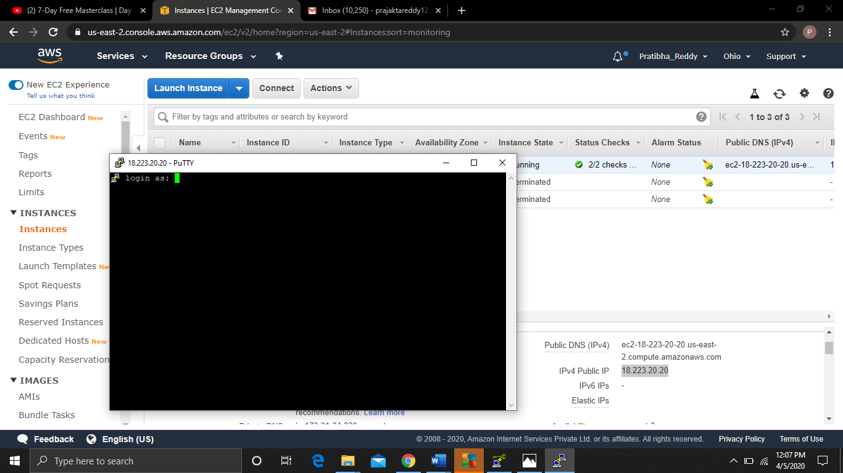

**12. CREATING A BUCKET**

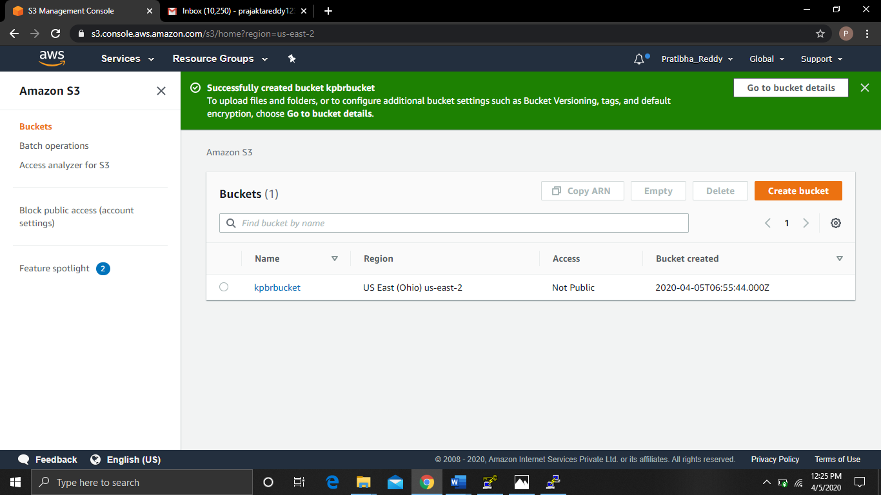

**13. UPLOADING AN OBJECT**

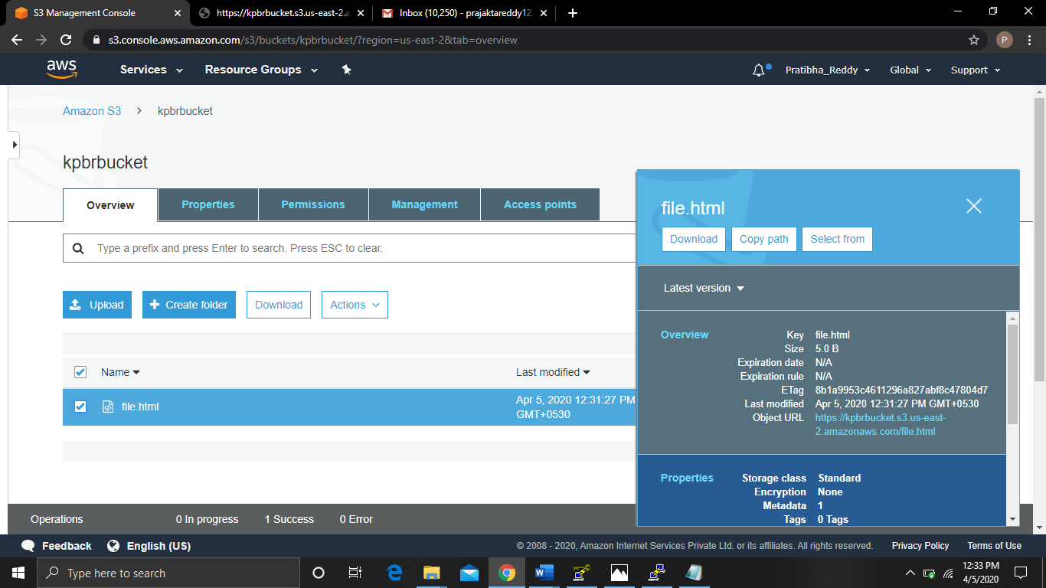

**14. ENABLING STATIC WEBSITE**

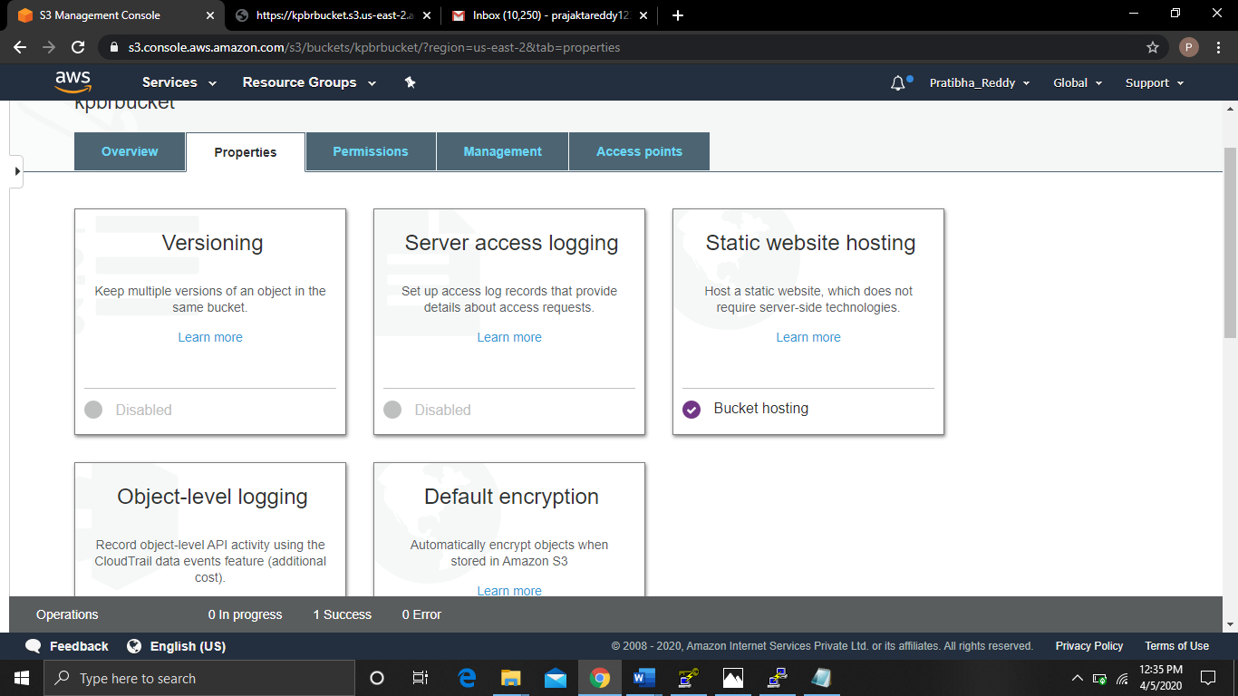

**15. MAKING THE OBJECT PUBLIC**

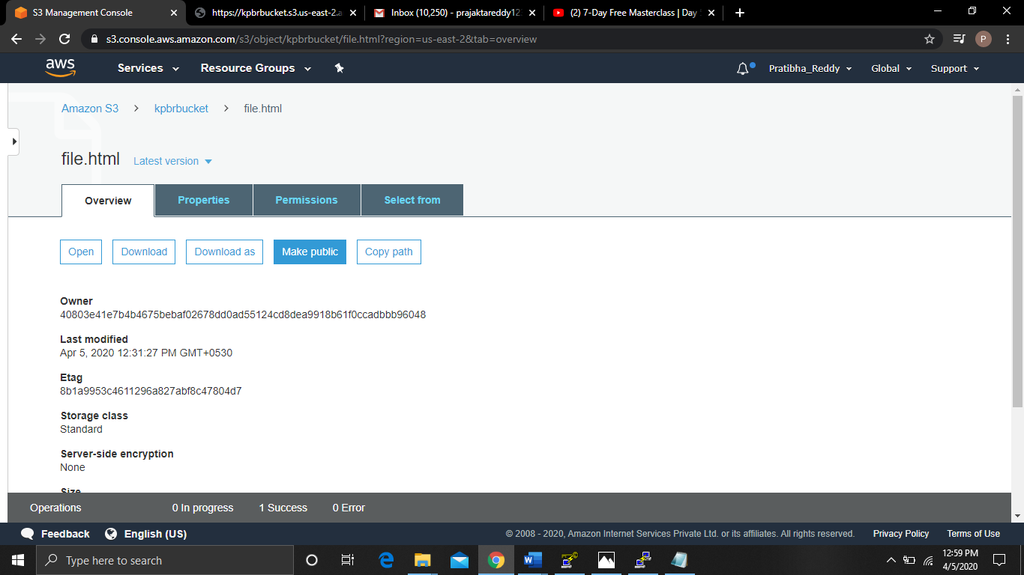

**16. CHECKING S3 LINK ON BROWSER**

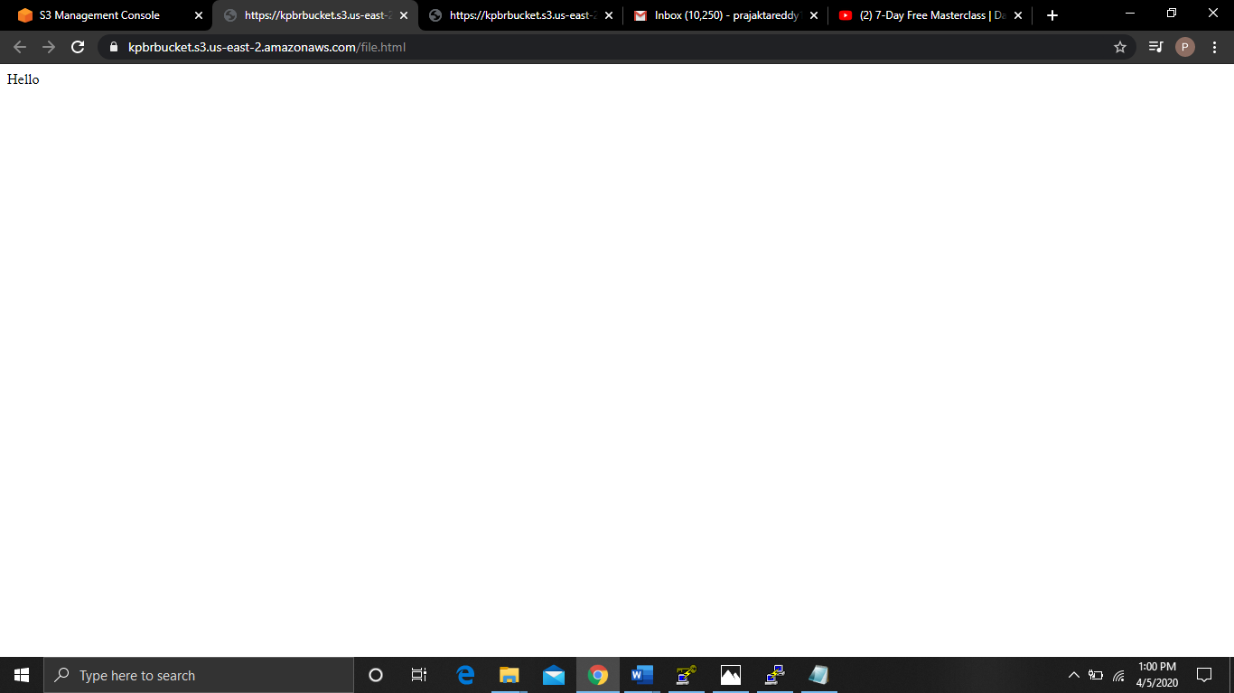

**17. FACE DETECT**

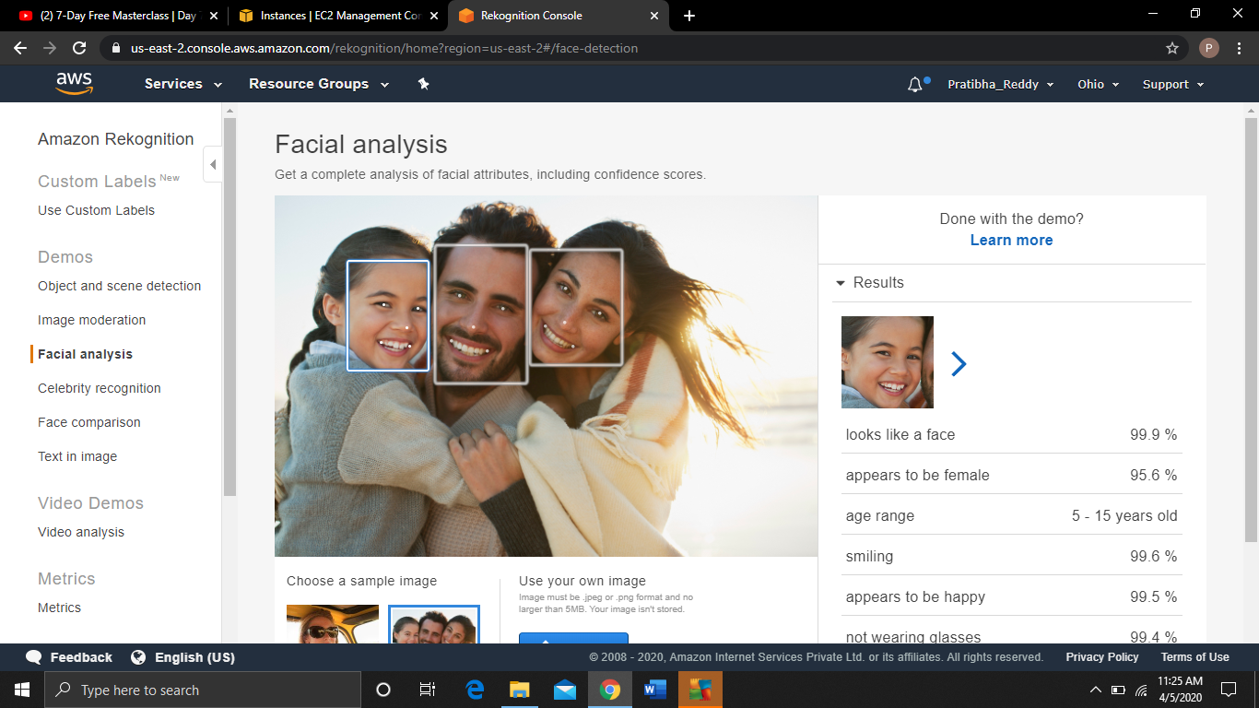

**18. FACE COMPARE**

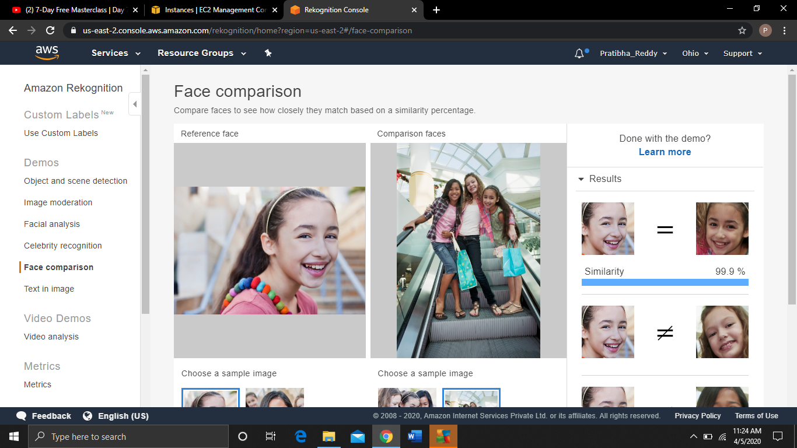

**19. CELEBRITY RECOGNITION**

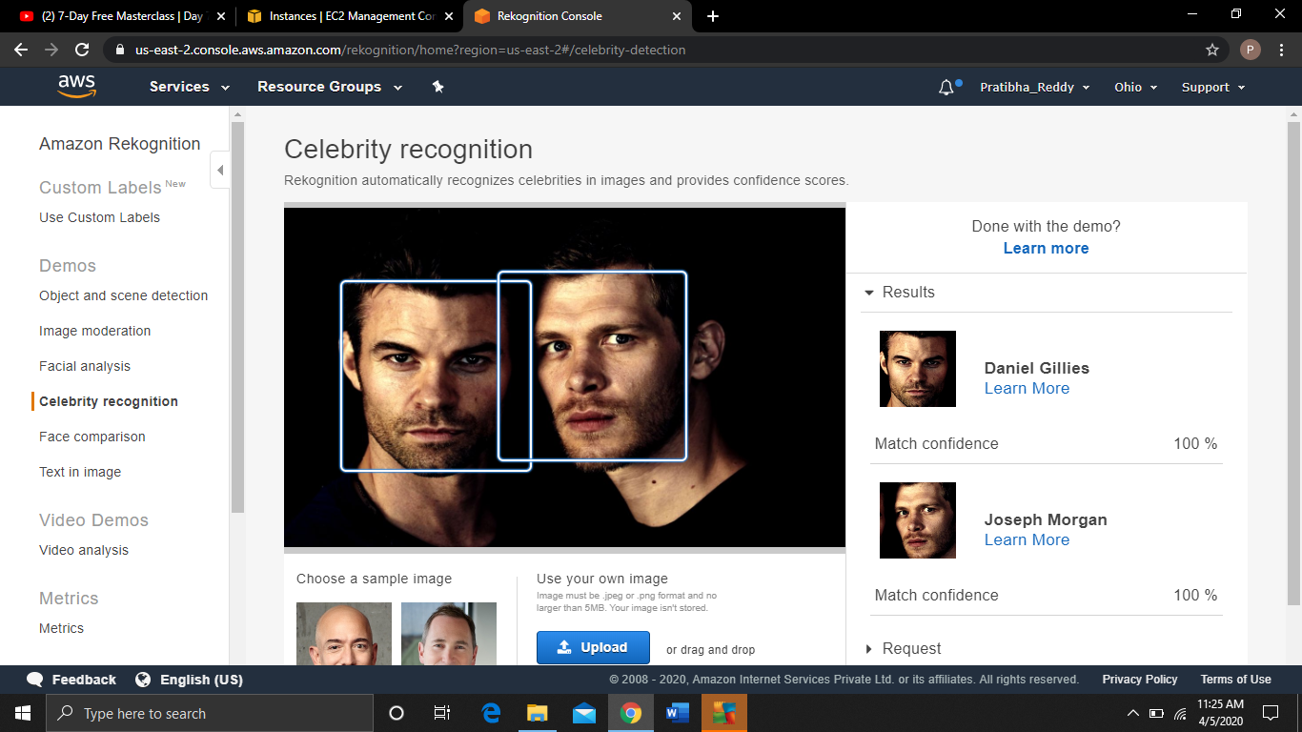

**20. TEXT IN IMAGE**

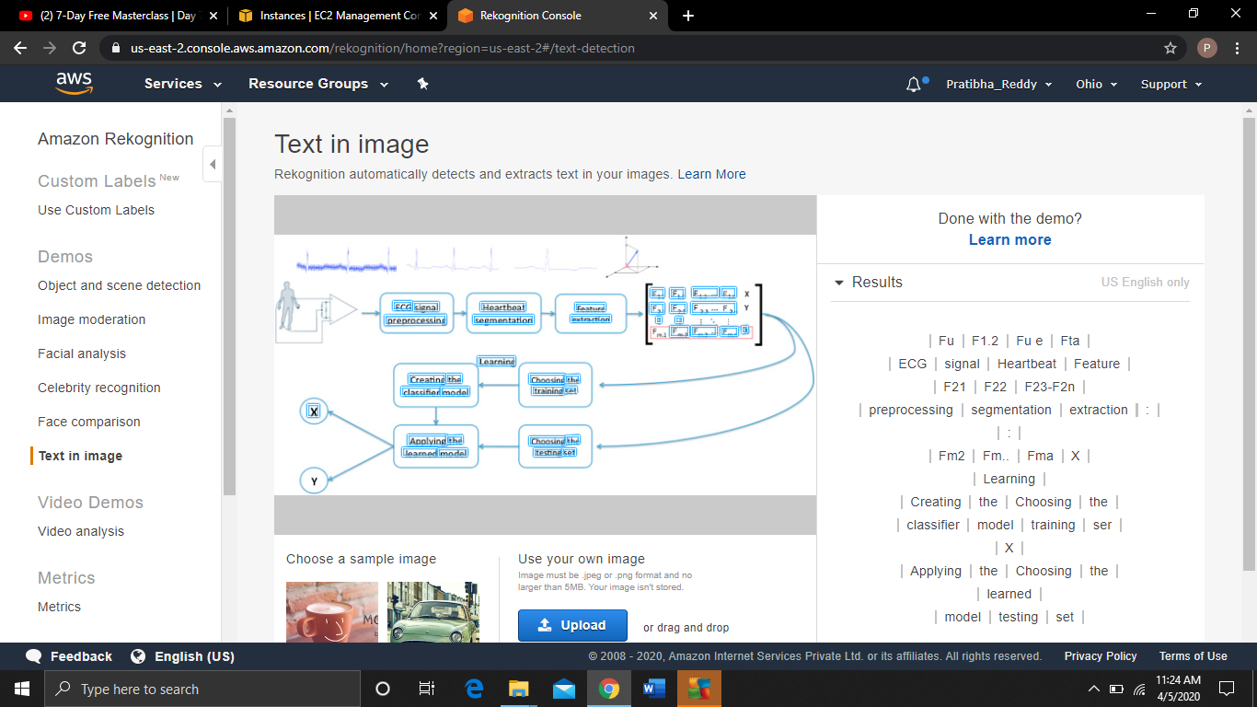

**21. INSTALLING PHP**

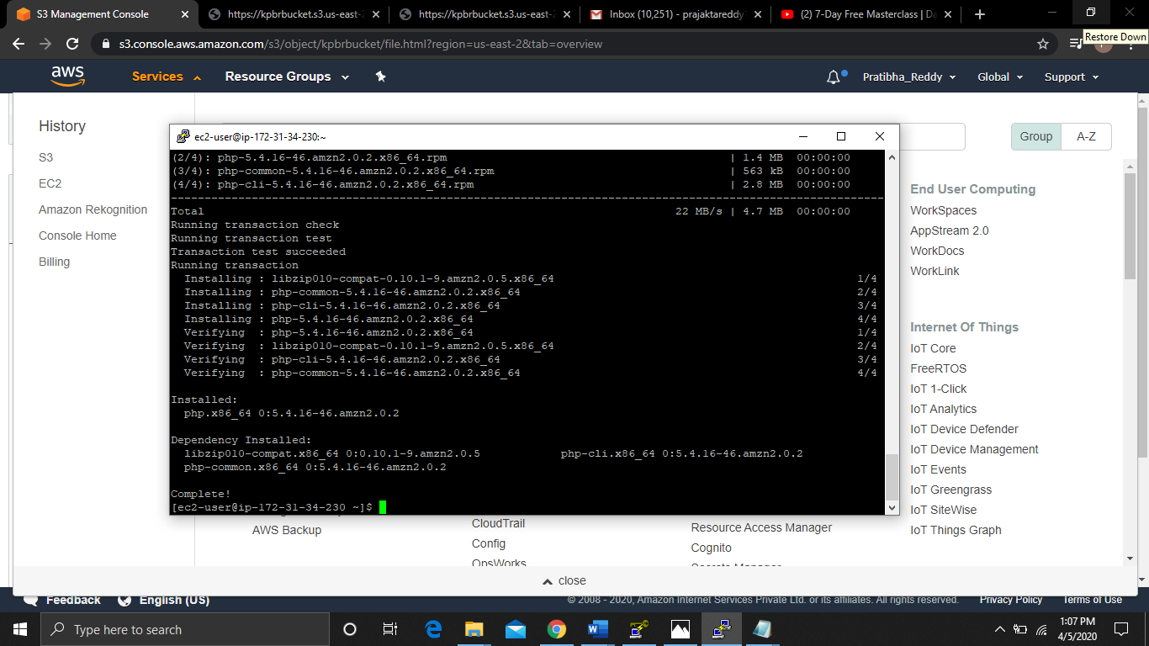

**22. INSTALLING AWS-SDK**

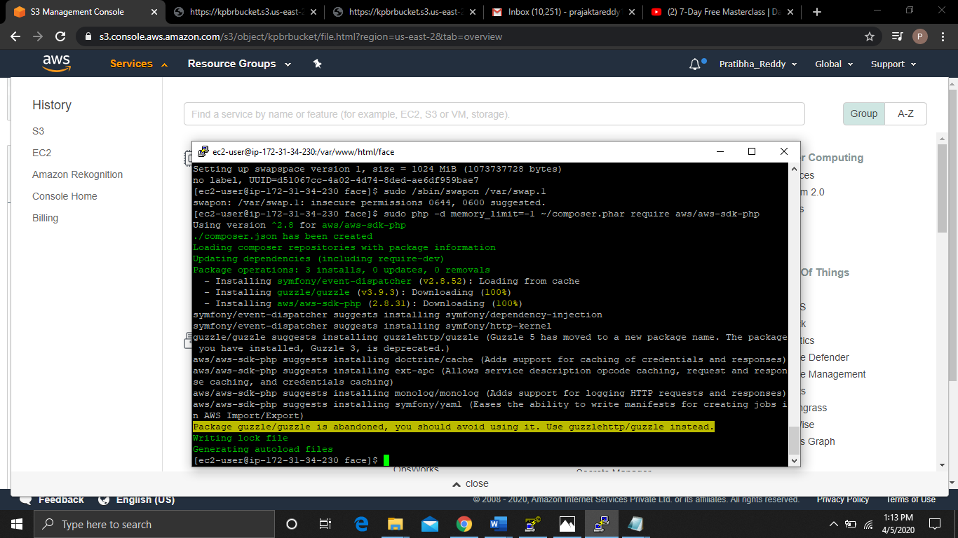

**23. INDEX.PHP FILE CODE**

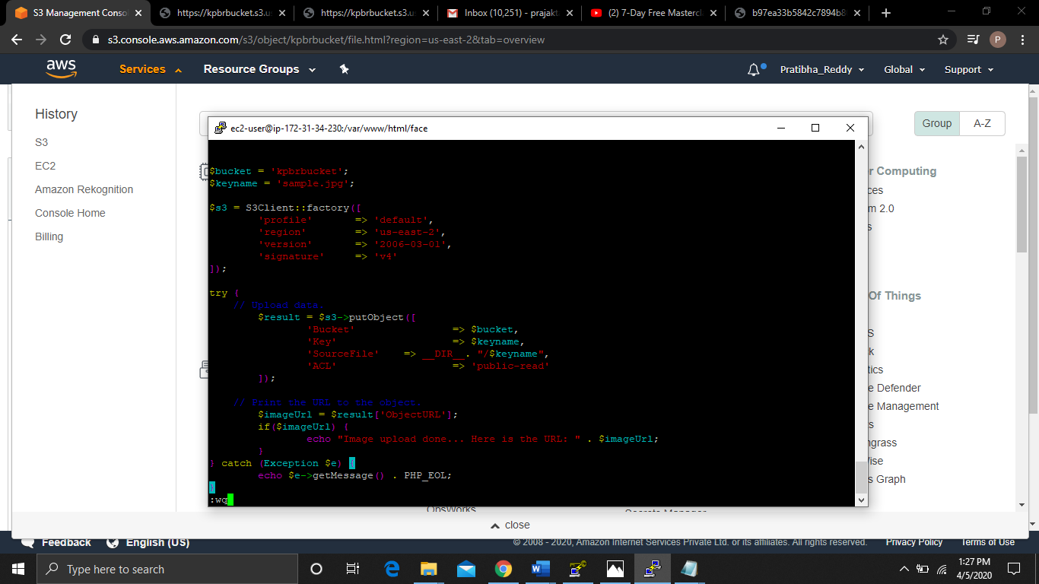

**24. IMAGE UPLOAD SUCCESS**

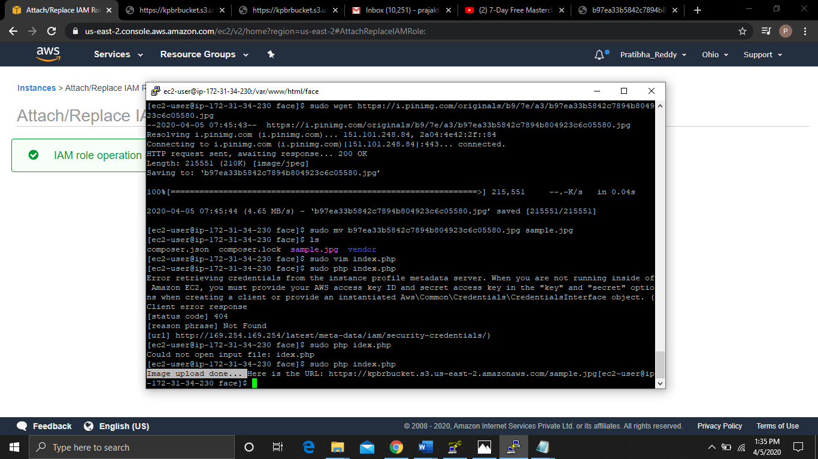

**25. FACE DETECT SUCCESSFUL**

